**TRABAJO PRÁCTICO N° 2:**

**AUTÓMATAS DE ESTADOS FINITOS Y MÁQUINAS DE TURING**

**Alumnos:**

* Marotta, Alejandro Adrián
* Soria Gava, Lucas Damián

**PARTE A: AUTÓMATAS DE ESTADOS FINITOS**

**Ejercicio 1:**

1. Que reconozca la expresión regular r’(b|(b*a)*)a’



1. Que reconozca la expresión regular r‘x(x|y)*’





**Ejercicio 2:**

1. (b | (b* a)*)a

Ɛ-cerradura({0}) = {0, 1, 2, 7, 3, 5, 10, 8} = A

Transiciones:

T(A,a):

* 0 - φ
* 1 - φ
* 2 - φ
* 7 - φ
* 3 - φ
* 5 - 6
* 10 - 11
* 8 - φ

Ɛ-cerradura({6}) = {6, 7, 10, 2, 3, 5}

Ɛ-cerradura({11}) = {11}

B = {6, 7, 10, 2, 3, 5, 11}

A ---a-->B

T(A,b):

* 0 - φ
* 1 - φ
* 2 - φ
* 7 - φ
* 3 - 4
* 5 - φ
* 10 - φ
* 8 - 9

Ɛ-cerradura({4}) = {4, 5, 3}

Ɛ-cerradura({9}) = {9, 10}

C = {4, 5, 3, 9, 10}

A ---b--->C

T(B,a):

* 6 - φ
* 7 - φ
* 10 - 11
* 2 - φ
* 3 - φ
* 5 - 6
* 11 - φ

Ɛ-cerradura({11}) = {11}

Ɛ-cerradura({6}) = {6, 7, 10, 2, 3, 5}

B ---a--->B (vuelve a sí mismo)

T(B,b):

* 6 - φ
* 7 - φ
* 10 - φ
* 2 - φ
* 3 - 4
* 5 - φ
* 11 - φ

Ɛ-cerradura({4}) = {4, 5, 3}

B ---b--->C

T(C,a):

* 4 - φ
* 5 - 6
* 3 - φ
* 9 - φ
* 10 -11

Ɛ-cerradura({6}) = {6, 7, 10, 2, 3, 5}

Ɛ-cerradura({11}) = {11}

C ---a---> B

T(C,b):

* 4 - φ
* 5 - φ
* 3 - 4
* 9- φ
* 10 - φ

Ɛ-cerradura({4}) = {4, 5, 3}

C ---b--->C (vuelve a sí mismo)



1. x(x|y)*

Ɛ-cerradura({0}) = {0} = 0

Transiciones:

T(0,x):

* 0 - 1

Ɛ-cerradura({1}) = {1, 2, 8, 3, 5} = A

0 ---x--->A

T(0,y):

* 0 - φ

T(A,x):

* 1 - φ
* 2 - φ
* 8 - φ
* 3 - 4
* 5 - φ

Ɛ-cerradura({4}) = {4, 7, 2, 8, 3, 5} = B

A---x--->B

T(A,y):

* 1 - φ
* 2 - φ
* 8 - φ
* 3 - φ
* 5 - 6

Ɛ-cerradura({6}) = {6, 7, 8, 2, 3, 5} = C

A---y--->C

T(B,x):

* 4 - φ
* 7 - φ
* 2 - φ
* 8 - φ
* 3 - 4
* 5 - φ

Ɛ-cerradura({4}) = {4, 7, 2, 8, 3, 5} = B

B---x--->B

T(B,y):

* 4 - φ
* 7 - φ
* 2 - φ
* 8 - φ
* 3 - φ
* 5 - 6

Ɛ-cerradura({6}) = {6, 7, 8, 2, 3, 5} = C

B---y--->C

T(C,x):

* 6 - φ
* 7 - φ
* 8 - φ
* 2 - φ
* 3 - 4
* 5 - φ

Ɛ-cerradura({4}) = {4, 7, 2, 8, 3, 5} = B

C---x--->B

T(C,y):

* 6 - φ
* 7 - φ
* 8 - φ
* 2 - φ
* 3 - φ
* 5 - 6

Ɛ-cerradura({6}) = {6, 7, 8, 2, 3, 5} = C

C---y--->C



**PARTE B: MÁQUINAS DE TURING**

**Ejercicio 1:**

1. Q = {q1, q2}

Σ = {a, b}

Γ = {a, b , ~~b~~}

s = q1

F = {q2}

δ dado por:

δ(q1, a) = (q1, a, R)

δ(q1, b) = (q1, a, R)

δ(q1, ~~b~~) = (q2, ~~b~~, L)

w = bbbab

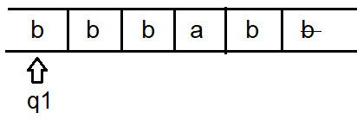

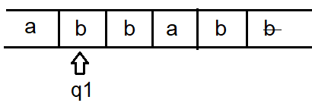

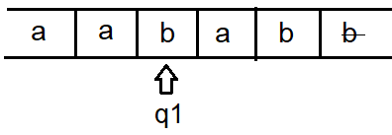

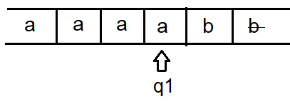

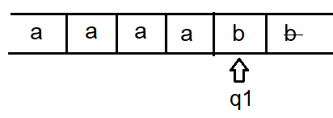

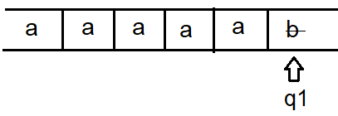

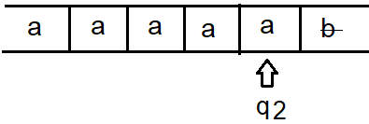

La máquina reconoce w = bbbab

1. Q = {q0, q1}

Σ = {0, 1}

Γ = {0, 1 , B}

s = q0

F = {q1}

δ dado por:

δ(q0, 0) = (q1, B, R)

δ(q0, 1) = (q0, B, R)

δ(q1, 0) = (q0, B, R)

δ(q1, 1) = (q1, B, R)

w = 01100

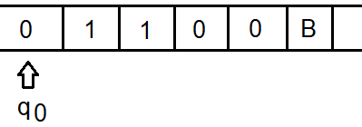

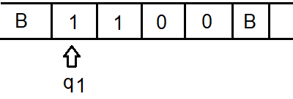

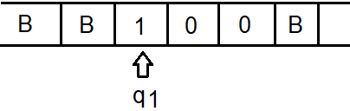

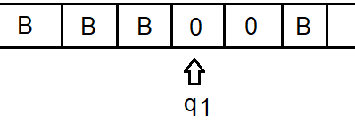

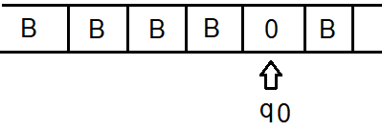

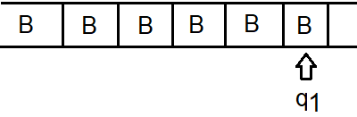

La máquina acepta w = 01100

**Ejercicio 2:**

1. (b | (b* a)*)a

Q = {A, B, C}

Σ = {a, b}

Γ = {a, b , ~~b~~}

s = A

F = {B}

δ dado por:

δ(A, a) = (B, a, R)

δ(A, b) = (C, b, R)

δ(B, a) = (B, a, R)

δ(B, b) = (C, b, R)

δ(C, a) = (B, a, R)

δ(C, b) = (C, b, R)

δ(B, ~~b~~) = (B, ~~b~~, L)

w = babaa

(A, babaa~~b~~) ⊢ (C, babaa~~b~~) ⊢ (B, babaa~~b~~) ⊢ (C, babaa~~b~~) ⊢ (B, babaa~~b~~) ⊢ (B, babaa~~b~~) ⊢ (B, babaa~~b~~)

La máquina acepta babaa

1. x(x|y)*

Q = {0, A, B, C}

Σ = {x, y}

Γ = {x, y , ~~b~~}

s = 0

F = {A, B, C}

δ dado por:

δ(0, x) = (A, x, R)

δ(A, x) = (B, x, R)

δ(A, y) = (C, y, R)

δ(B, x) = (B, x, R)

δ(B, y) = (C, y, R)

δ(C, x) = (B, x, R)

δ(C, y) = (C, y, R)

δ(A, ~~b~~) = (A, ~~b~~, L)

δ(B, ~~b~~) = (B, ~~b~~, L)

δ(C, ~~b~~) = (C, ~~b~~, L)

w = xyxxy

(0, xyxxy~~b~~) ⊢ (A, xyxxy~~b~~) ⊢ (C, xyxxy~~b~~) ⊢ (B, xyxxy~~b~~) ⊢ (B, xyxxy~~b~~) ⊢ (C, xyxxy~~b~~) ⊢ (C, xyxxy~~b~~) ⊢ (C, xyxxy~~b~~)

**Ejercicio 3:**

**Ejercicios de python en los archivos .py comprimidos juntos con este documento**

Tablas de transiciones:

1. (b | (b* a)*)a

|  |  |  |  |
| --- | --- | --- | --- |
| **Estado** | **a** | **b** | **FDC** |
| A | B | C | Error |
| B | B | C | Aceptación |
| C | B | C | Error |

1. x(x|y)*

|  |  |  |  |
| --- | --- | --- | --- |
| **Estado** | **x** | **y** | **FDC** |
| 0 | A | Error | Error |
| A | B | C | Aceptación |
| B | B | C | Aceptación |
| C | B | C | Aceptación |